**NATIONAL UNIVERSITY OF SCIENCES AND TECHNOLOGY**

**SCHOOL OF MECHANICAL & MANUFACTURING ENGINEERING (SMME)**

**CLASS :** BE Mechanical Sec-B ( 1st Semester )

**COURSE :** Computer Science & Programming

**LAB Home Task 1**

**TOPICS:** Factorial of 6, Distance formula, conversion into m & km, Mathematical formula.

**INSTRUCTOR**: Sir Muhammad Affan

Submitted by Muhammad Rayyan

Roll no: 456847

Submission Date: 4-oct-2023

**Department of Manufacturing Engineering (DME)**

**CAD / CAM Lab**

**Task 1**

“calculating the factorial of 6”

#include<iostream>

using namespace std;

int main(){

int x;

cout<<"calculating factorial of x"<<endl;

cout<<"here particularly x = 6"<<endl;

cout<<" enter value of \"x\": "<<endl;

cin>>x;

cout<<(x)*(x - 1)*(x - 2)*(x - 3)*(x - 4)*(x - 5);

return 0;

}

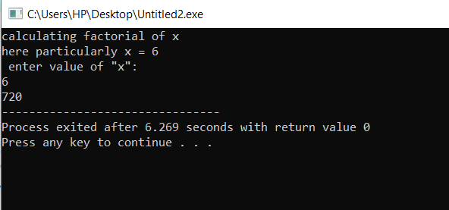

**Task** **2**

“Calculating the distance btw 2 points using distance formula”

#include<iostream>

#include<cmath>

using namespace std;

int main(){

float x1,x2,y1,y2;

cout<<"enter x1"<<endl;

cin>>x1;

cout<<"enter x2"<<endl;

cin>>x2;

cout<<"enter y1"<<endl;

cin>>y1;

cout<<"enter y2"<<endl;

cin>>y2;

cout<<pow((pow((x1-x2),2) + pow((y1-y2),2)),0.5)<<endl;

return 0;

}

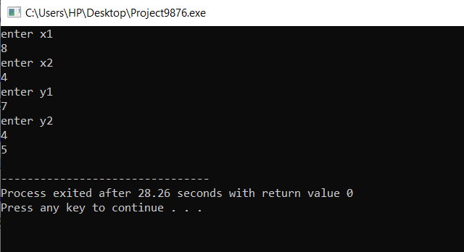

**Task** 3

“Converting length in cm to m and km“

#include<iostream>

using namespace std;

int main(){

float cm;

cout<<"enter value of length in cm"<<endl;

cin>>cm;

cout<<" the value of length in m "<<endl;

cout<<(cm/100)<<endl;

cout<<" the value of length in km"<<endl;

cout<<(cm/100000)<<endl;

return 0;

}

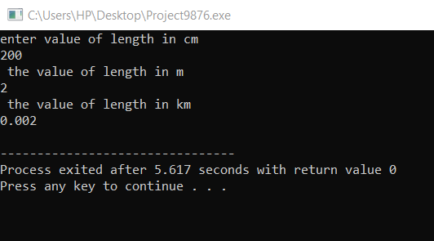

**Task 4**

“Calculating polynomial a2 + 2ab + b2 “

f

#include<iostream>

#include<cmath> //TASK 3

using namespace std;

int main(){

int a,b ;

cout<<"enter value of a"<<endl;

cin>>a;

cout<<"enter value of b"<<endl;

cin>>b;

cout<<"the required ans of polynomial is"<<endl;

cout<<(pow(a,2) + (2*a*b) + pow(b,2));

return 0;

}

